(SharePoint Deployment Policy)

## Document Control and Change management

# Deployment Checklist

According to the adapted policy, deployment checklist will effect Admin and developers roles

Guidelines to these roles are in the following sections.

## Guidelines to Admins

1. Must deploy all deployments on Staging First.
2. Do not accept any deployment files if they are not in WSP format, i.e. no separate deployment of DLLs or images, css or javascript/jQuery files.
3. Production deployment must be after 3:30 PM in other words no Production deployment with in the working hours (unless approved by Department Manager of requesting department).
4. Upon getting the confirmation of Stage deployment from Developer or Project Manager and request to proceed for production, admin can deploy the production deployment.
5. Before deployment on production, Admin should extract the solution as a backup in case the developer request to revert the solution to previous build or version.
6. In case of exception and urgency or any critical circumstances where developer request the Production deployment with in working hours developer/PM must provide the approval from higher management of i.e. Managers of business and technical team.
7. Global Assembly Cache (GAC) Deployments will not be accepted unless Technical justification is provided and accepted by SharePoint team.
8. Solutions/WSP Names should follow the proper naming conventions (that can be checked with SharePoint team)

## Guidelines to Developers

1. Before sending any deployment, it should be tested in partner/supplier test environment, which is the exact replica of Staging and Production environments.
2. Must not send any deployment, which is not part of WSP package, No manual copy to hive folder (SharePoint Binaries Folder), or Virtual folders, all customization should be packaged in WSP.
3. Must not send huge WSP files, which cause issues on the servers. File size should be within acceptable range otherwise consider splitting the packages in several files. SharePoint team recommends not exceeding the size above then 30 MB. It is highly recommend to deployment packages using Dropbox or any other similar service.
4. Developer must provide all prerequisites needed for deployment.
5. Developer must provide detailed deployment/retraction steps.
6. Developer must provide how to validate deployment i.e. how to make sure that package was deployed successfully.
7. All features and WSPS have appropriate name and start with . (namespace should be proposed by SharePoint team)
8. Deployment of Web services created in .NET should be out of SP Environment (farm).
9. Prior to moving to Production, developer must test each package on Stage first.
10. After testing the developer must confirmed the deployment in order to move the same package for Production
11. After the Production, deployment acknowledged by the admin then developer must check and confirm the deployment.
12. After testing the developer must confirmed the deployment and send request to admin in order to move the same package for production
13. After the Production deployment, acknowledged by the admin, developer must check and confirm the deployment.
14. GAC Deployments will not be accepted unless Technical justification is provided and accepted by SharePoint team.
15. Solutions/WSP Names should follow the proper naming conventions (that can be checked with SharePoint team)
16. No Server side Open source solutions should be used in the provided WSPs.
17. Avoid adding site settings into Web.config file, instead use Configuration lists (custom lists with controlled permissions) or Put them in Custom Database.

## Deployment Process

Deployment process starts from developer who send the request via sending email attachments (not recommended) or with download links, developer also provide the Team Foundation Server (TFS) entry containing Release notes and deployment instructions (including Power-Shell Scripts for complete deployment process. Target URLs can be taken from SharePoint Admins at any time).

Every new deployment must be approved by the Head of Application Development, Upon receiving the deployment request from the developer, SharePoint admin check the approval status if the deployments is new he get the approval from the manager if its existing he proceeds to Staging deployment once deployed he sent the acknowledgement to developer by replying the email.

Upon receiving the deployment confirmation from admin, developer check the SharePoint website and tests that whether the desired changes has been reflected in the solution and desired state or results has been achieved. After testing, he or she send the confirmation to the admin and could request to proceed for Production deployment.

Upon receiving the request admin take the backup of the current WSP solution by extracting it, and proceed for the production, once deployment has been done and admin check the site if it is working fine after the deployment and web application service started after the deployment, the he will send the deployment confirmation to developer.

Upon receiving the confirmation from admin, developer check the SharePoint site and test the solution and confirm back the Admin through replying email (expected response time 1 hour at max) if the desired state or results has been achieved on production environment.

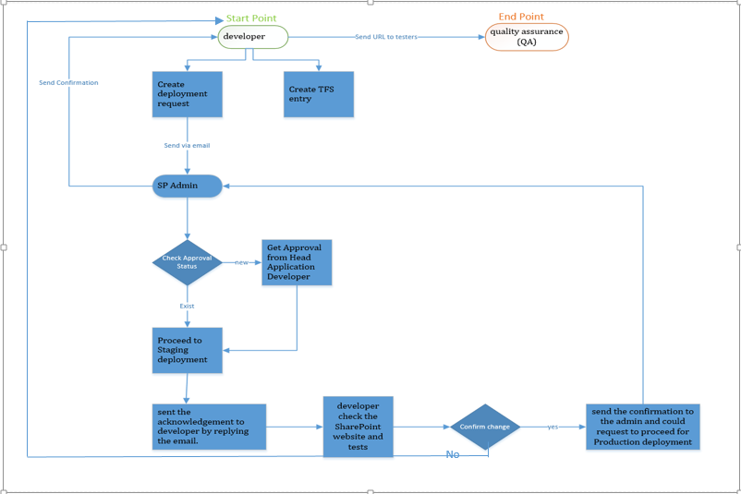

## General Deployment Policy

We have to schedule routine server & SharePoint maintenance, which is very important to keep the environment healthy, stable & available. Please share your future deployment plan with us ASAP, so we can schedule the maintenance in a different time slots.

As long as you have Development and/or Pre-Staging environment we highly recommend you to deploy the package there and request the stakeholders to test initially and upon getting approval from stakeholders you can send it to us to deploy it on Stage 🡺 Prod.

In addition, we are requesting to keep the maximum 2 Major deployment per week due to same above reasons because each major deployment is causing effect on SharePoint farm in terms of stability and availability.

* **Major Deployment ( 2 Maximum Per week – should be scheduled at least one week minimum one week earlier) : More than 3 WSPs** (solution packages)

**For Major deployments will be held every Sunday and Wednesday.**

* **Minor Deployment ( 1 Maximum per day – should be scheduled minimum 1 day earlier) : Less than 3 WSPs**

There are many other factors, which are also affecting the Farm health like Size of WSPs and architecture used in the overall sites.

Please if you have more than one project deployment at same time, please prioritize it based on your business needs, as we cannot install them in parallel.

Please note that our working hours are 8.00am till 5.00pm and we are accepting deployment requests max by 1PM for Stage or Production.

* Stage Deployment will be done on same day and time if no other tasks are in Queue and we send you response in same working day.
* Production Deployments will be started after 3.30pm and depends on number of WSPs; the whole process will took time accordingly. If you want to go live on same day then send us WSPs by 12PM for stage deployment so you can get our early response for validation before moving them to production. These all aspects should be covered in your release-planning document as requested above.

Only items created with TFS will be entertained. The format of TFS task should be like “Deployment-DD-MM-YYYY 🡺 Subject Line “and provided with release notes properly written in English.  Upon confirmation of deployment in (Stage or Production), please close the task as we are expecting from you to accept the work done by us.